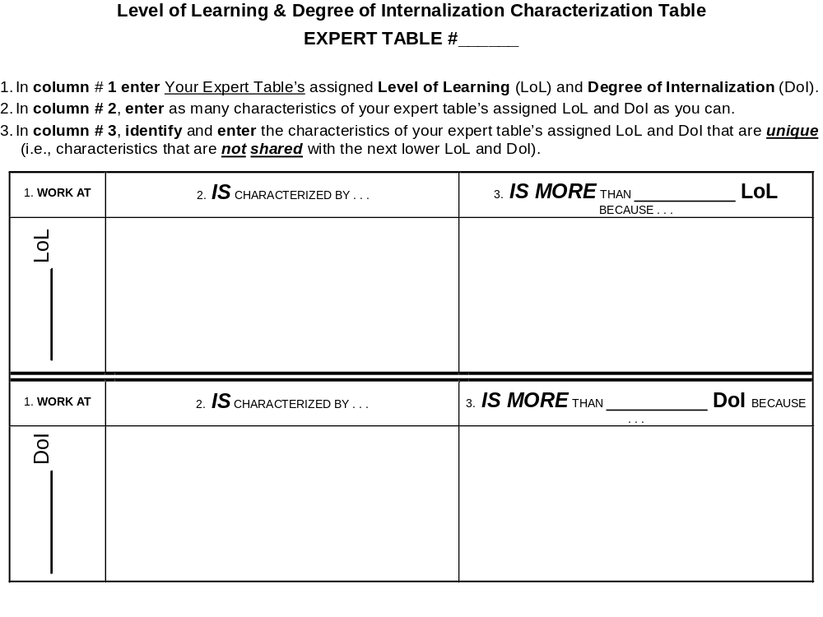
Page 1 of C_6_1

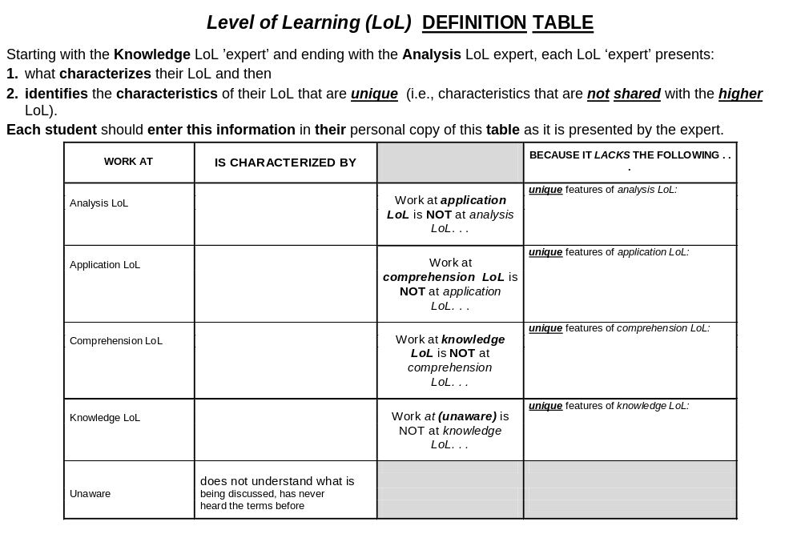
Page 2 of C_6_1

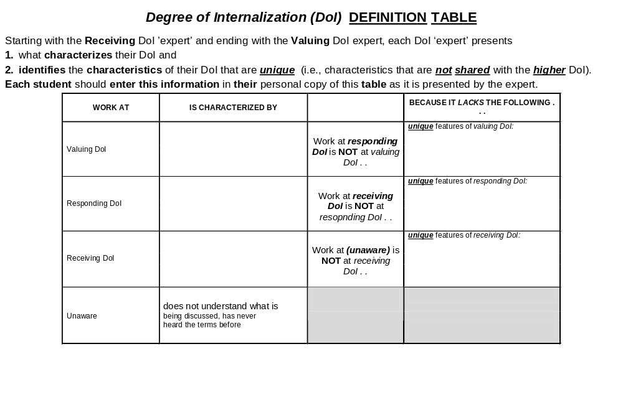
Page 3 of C_6_1

Level of Learning (LoL) WORK PRODUCT ASSESSMENT EXAMPLE
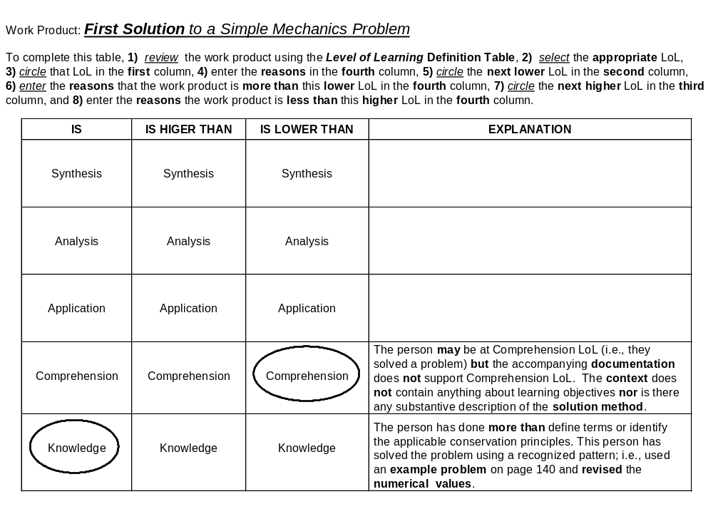

Page 4 of C_6_1

Degree of Internalization (DoI) WORK PRODUCT ASSESSMENT EXAMPLE
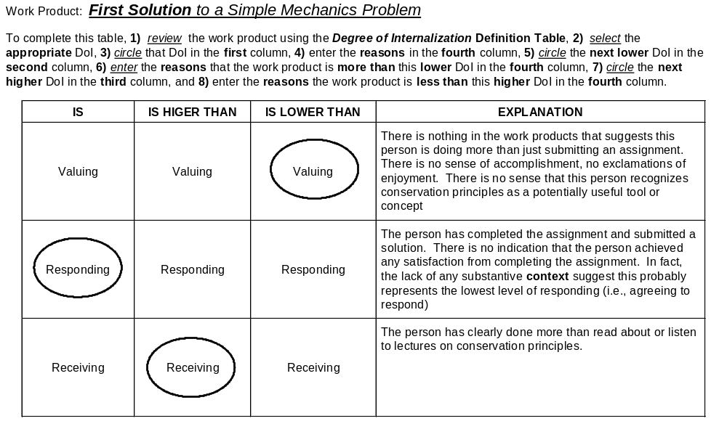
Page 5 of C_6_1

Level of Learning (LoL) WORK PRODUCT ASSESSMENT TEMPLATE
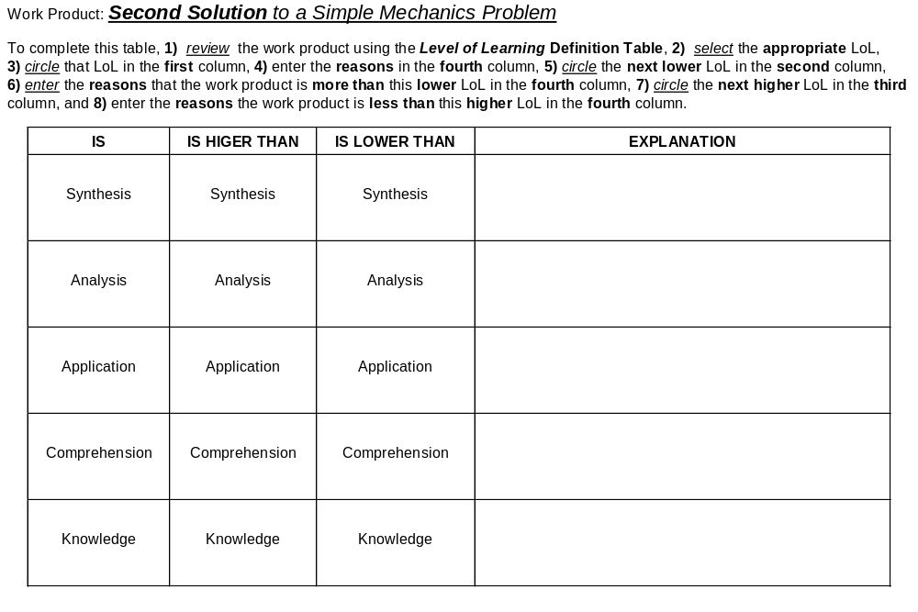
Page 6 of C_6_1

Degree of Internalization (DoI) WORK PRODUCT ASSESSMENT TEMPLATE
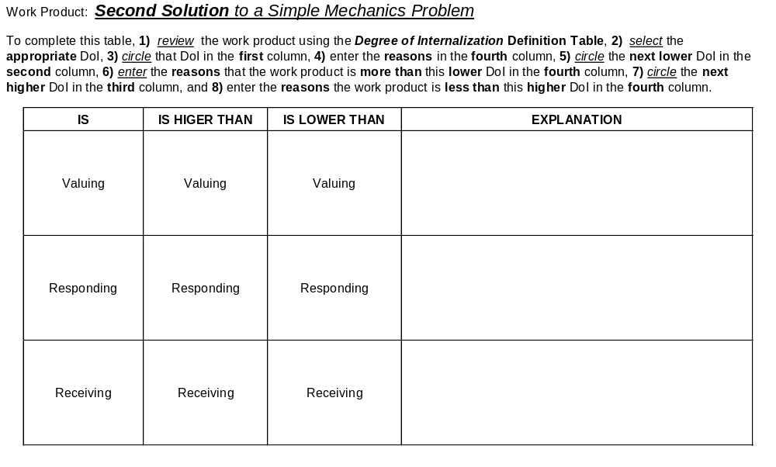
Page 7 of C_6_1

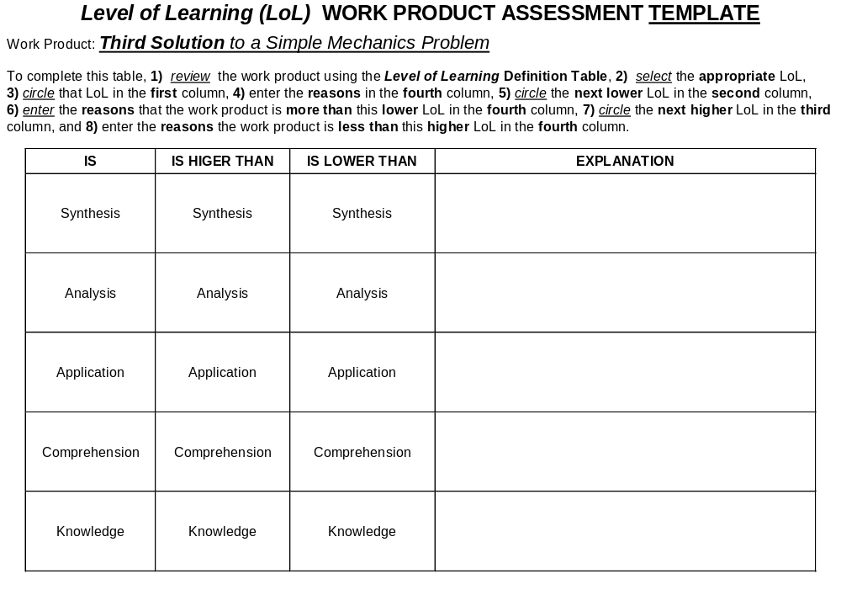
Page 8 of C_6_1

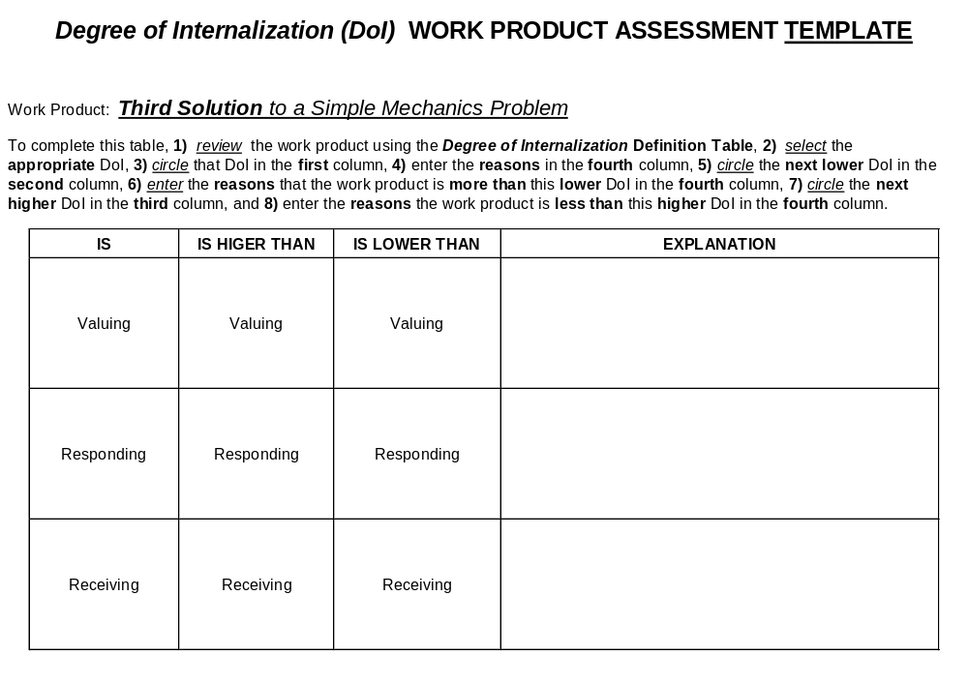

Page 9 of C_6_1

